**Customizable Email Templates**

*Announcement Template—Monthly Discussion*

[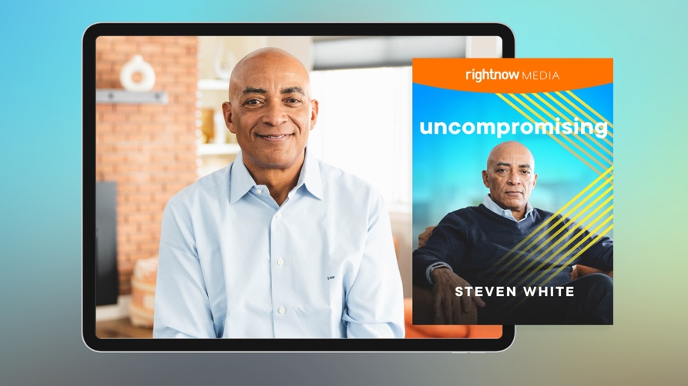](https://app.rightnowmedia.org/en/content/details/794350)

Team,

This month we’ll spend time as a team going through [*Uncompromising*](https://app.rightnowmedia.org/en/content/details/794350)with keynote speaker and Comcast executive Steven White on RightNow Media @ Work. I chose this series to help us learn how we can lead a life of purpose, success, and fulfillment.

Over the next month, please find time to watch this eight-session series on your own. In addition to watching the series, note your answers the below questions. We may not discuss every question, but I would like each person to be prepared to give your input if asked.

* [REVIEW QUESTION BANK AND INCLUDE 5-6 QUESTIONS HERE]

Please complete everything prior to [DATE], which is when we will discuss this series in our team meeting. If you haven’t registered your free RightNow Media @ Work account yet, here’s the link to do so: [INSERT CUSTOM LINK—LOG IN TO YOUR ACCOUNT, CLICK ‘SEND INVITE’ IN TOP RIGHT, THEN CLICK ‘COPY INVITE LINK’ BUTTON. CONTACT YOUR CONSULTANT FOR ADDITIONAL HELP OR QUESTIONS.]

Let me know if you have any questions. I look forward to discussing this series together.

*Announcement Template—Weekly Discussion*

](https://app.rightnowmedia.org/en/content/details/794350)

Team,

This month we’ll spend time as a team going through [*Uncompromising*](https://app.rightnowmedia.org/en/content/details/794350)with keynote speaker and Comcast executive Steven White on RightNow Media @ Work. I chose this series to help us learn how we can lead a life of purpose, success, and fulfillment.

Each week you’ll watch two sessions from the series and make note of your answers to the questions for that session (provided via email). We’ll then get together each week to discuss those sessions and the team’s responses. For our first discussion on [DATE], consider these questions as you’re watching sessions 1 and 2:

* [REVIEW QUESTION BANK FOR SESSIONS 1 & 2 AND INCLUDE TWO QUESTIONS HERE.]

If you haven’t registered your free RightNow Media @ Work account yet, here’s the link to do so: [INSERT CUSTOM LINK—LOG IN TO YOUR ACCOUNT, CLICK ‘SEND INVITE’ IN TOP RIGHT, THEN CLICK ‘COPY INVITE LINK’ BUTTON. CONTACT YOUR CONSULTANT FOR ADDITIONAL HELP OR QUESTIONS.]

Let me know if you have any questions. I look forward to discussing this series together.

*Reminder Template*

*Tip: You can reply all to your previous announcement email so your team has easy access to the questions you sent over in the original email.*

Team,

Just a reminder that we’ll be discussing the [*Uncompromising*](https://app.rightnowmedia.org/en/content/details/794350) series with Steven White at our team meeting [next week / tomorrow].

* Make sure you’ve signed up for your free RightNow Media @ Work account: [INSERT CUSTOM LINK]
* Watch [the series here](https://app.rightnowmedia.org/en/content/details/794350) (available on desktop, mobile, or TV streaming devices).
* Answer the questions I previously sent over in preparation for our discussion.

Let me know if you have any questions. I look forward to discussing this series together.

*Weekly Question Email Template*

Team,

For next week’s discussion, watch sessions [X and X] of the [*Uncompromising*](https://app.rightnowmedia.org/en/content/details/794350)series with Steven White on RightNow Media @ Work. Consider these questions as you’re watching:

* [REVIEW QUESTION BANK FOR THIS SPECIFIC SESSION AND INCLUDE 2-4 QUESTIONS HERE.]

Let me know if you have any questions. I look forward to discussing this series together.

**Question Bank**

*From session 1:*

* Steven shared some of his values in the video, showing us how our background can set a foundation for our future. He said that his upbringing grounded him in values like hard work, a great attitude, teamwork, family, and not letting his surroundings shape his expectations. **Who has helped shape you as a person? What values or beliefs did they instill in you?**
* Steven also told us about the power of belief. You must set big goals and believe that you can reach them. Doubt and pessimism will slow you down and keep you from finding the success you want to achieve. **In what ways can a bad attitude or self-doubt sabotage your goals? What could you do to confront that attitude so it does not cheat you out of success?**
* Your beliefs ground you in truth. Your expectations empower you to achieve your purpose. **Consider your beliefs and hope for the future—what is your personal “why”? Try to state your purpose in a single sentence.**

*From session 2:*

* It may take time to identify and clarify your purpose. In the meantime, there are ways to continue your discovery process. Through personality assessments, asking yourself probing questions, and discussing your purpose with a trusted mentor, you can continue to uncover what makes you tick. **In what ways are you seeking your “why”? Who could help you clarify your purpose?**
* Finding our fight requires us to identify our “why” by understanding what we are good at and passionate about. We must then embrace our fight by surrounding ourselves with a supportive system both professionally and personally. **What step can you take this week to connect your why to the support system around you so you can fully pursue a meaningful legacy?**

*From session 3:*

* There are multiple ways we can keep our focus on the real prize. First, we should set daily reminders of our “why.” Steven said he starts each day with prayer and reflection, but your daily reminder could look different. What is important is to set your focus every morning on what matters most. **What reminders—morning exercises, repeated mantras, written reminders, etc.—could help you keep your “why” at the forefront of your mind?**
* Steven made the point that we should suspend our disbelief and look forward to a better, more hopeful day. Hope is a powerful motivator that’s able to keep us moving forward even when the future is full of obstacles. **What better future are you looking forward to? Is that big hope worth fighting for? How might you motivate yourself to keep going?**
* Distraction and disappointment are threats, but threats that can be overcome. When we determine to remain positive and stay focused, there is nothing that can stand in our way. **What steps can you take to apply Steven’s points this week?**

*From session 4:*

* Many of us find ourselves making the same mistakes over and over in our careers and personal lives. Your ability to learn and grow will prevent you from making past mistakes and repeat practices that lead you to success. **What problems do you repeatedly face in your career?** **What could you learn from those problems? What mindset or ideas keep leading you back to those problems?**
* Steven’s second point was to let curiosity create a fierce independence. You alone are responsible for bringing your ideas to life. Curiosity will help you discover how to achieve your goals. **What ideas or goals are you hoping to make a reality? In what ways, if any, do you need to take more responsibility for those ideas and goals?**
* “If you're not growing,” Steven said, “if you're not learning, you're staying in place and you're falling behind. Your ability to live your best life is all about constantly growing, constantly learning. The only way you do that is through humility and modesty, recognizing that you don't know everything.” **What, specifically, do you still need to learn? In what ways could you be humbler about what you don’t know and more eager to learn?**

*From session 5:*

* You are the CEO of your life—you oversee the decisions you make, the people you surround yourself with, and the way you use your resources. **Take a moment to assess your performance. What are your strengths and weaknesses? What goals are you prioritizing? What resources will you need to reach your goals?**
* One way we can adopt an owner’s mentality is by considering our long-term future, not just our short-term goals. Think about where you want to be by the end of the year or in the next five years. **Where do you see yourself in five years? What will it take for you to reach that goal? What needs to change today to reach that ideal future?**
* Steven’s final step in this pathway was to earn it. There are no shortcuts in life. Success requires hard work. Putting in uncompromising effort may seem daunting, but it can be managed in increments. **What is one thing you can do to put your best foot forward this week?**

*From session 6:*

* Steven shared that control is an illusion. Giving up control may initially feel stressful, but we will enjoy life more once we realize that we control very little. You don’t have to stress over tomorrow or waste energy on things that you cannot change. **What uncontrollable aspects of your life cause you the most stress? In what ways do you try to determine or control those aspects of your life?**
* Steven challenged us to feed the positive and starve the negative in our lives. He was not encouraging us to ignore serious issues, but to see the positive in every situation and hope for a better tomorrow. **What difficult issues are demanding your attention? What negativity are they bringing into your life? What would it look like to see those issues in a positive light?**
* Life is full of risks, challenges, and unforeseen problems, but we don’t have to fear the future. We can choose to react positively to every situation, hope for a better tomorrow, and surround ourselves with people who bring the best out of us. **What circumstances can you approach with a more positive attitude? What good things are in your future? What can you do today to take radical responsibility for your attitude?**

*From session 7:*

* Life is full of ups and downs—uncertainty is guaranteed. But we don’t have to worry about what will come our way. Steven suggested starting each day with a positive perspective. For Steven, that means starting each day with prayer and counting his blessings. **What new practices could help you start each day on a positive note?**
* Uncertainty oftentimes brings struggles that threaten to stop us from pursuing our dreams. Steven helped us confront our tendency to withdraw with his third point: stay in the game. **Has uncertainty prevented you from pursuing an opportunity? If so, what could you learn from that decision?**
* Finally, Steven said we should regularly take time to reflect and evaluate our progress. **Think about where you are today—are you on the right path, moving toward your purpose? How might stopping to evaluate yourself help you be thankful for your current position?**

*From session 8:*

* It can be tempting to only commit to people when it helps our bottom line, but Steven asked us to think about what we can give to others. He said, “When we develop and maintain committed relationships where we give and receive, we create a legacy that leaves an enduring positive difference on the world.” **Why do you think we gravitate toward friendships that benefit us? What would it look like to be a person who is committed to benefitting others?**
* Our investment in others should not be a one-time deposit. When we commit to long-term relationships, we not only help others but can benefit from their influence in our lives. **Who around you can you invest in long-term?**
* These pathways will carry us through every circumstance and guide us to meaningful success. Each pathway is essential to our pursuit of lasting fulfillment. **Which pathway stands out to you as you move forward on your journey? In what ways will adopting Steven’s guidance help you find more fulfillment, success, and impact?**

*Tip: Additional questions can be found in the free series study guide* [*on RightNow Media @ Work here.*](https://reader.rightnowmedia.org/2381/808094)